**Composite Cryogenic Fuel Tank**

ME 492 Capstone- Project Contract

Team Lead: Alex Farias

Team Members: Neil Benkelman, Russell Berger, Francesca Frattaroli, Weldon Peterson, Christopher Wilson

**Client/Market Requirements**

**Constraints**

* The tank must be able to contain cryogenic liquids without leaking
* The tank must be lighter than conventional metal tank
* That tank will use material that is inert with liquid oxygen
* The tank must integrate with the LV4 rocket’s modular airframe design

-The above constraints are *requirements* of the project in order for this composite tank design to be feasibly viable as a flight-ready product. Due to the nature and volatility of the fuel being used in the tank (liquid oxygen), any leakage that occurs in the final design would lead to catastrophic failure. One of the most important applications of this fuel tank is the fact that it will contribute to a significant reduction in weight when compared with a conventional aluminum tank used in rocket applications. This factor is especially important when taken under consideration with the overall LV4 rocket design project by the sponsor, PSAS. Creating a composite fuel tank with said weight reduction will allow the rocket to carry heavier payloads to low earth orbit, as well as reduce overall fuel costs if heavier payloads are not required.

-An additional constraint that must be considered is the separation issue between the aluminum and carbon fiber interface. Due to the thermal properties of carbon fiber in relation to aluminum, the carbon fiber has a negative coefficient of thermal expansion, which will cause the material to expand once the temperature begins to drop, causing separation from the aluminum as it will contract due to a temperature drop. This constraint will be dependent on the design, as if a design is selected that does not involve an aluminum component during the layup process, this issue has the potential to be avoided entirely.

**Success Measures**

* Maximum working pressure of the tank
* Secure additional funding from the Oregon Space Grant Team Experience Award, this will allow us to purchase materials with better performance
* weight/volume ratio
* Manufacturing consistency (manufacturability)
* Full scale achievable?
* How long the fuel will stay liquid in tank

-One of the more important measures of success for this project is the maximum amount of pressure this tank will be able to withstand before failing. Due to the interconnected nature of the overall LV4 Rocket Project by PSAS, the tank must be able to maintain the LOX fuel at a sufficient pressure, which will in part be dictated by the Electronic Feed System Capstone project. If the tank cannot maintain a sufficiently high pressure, the composite fuel tank becomes significantly less feasible, and as well will affect the feasibility of other aspects of the overall LV4 project.

-Manufacturing consistency is also a very important success measure, as reproducibility in the design and project is strongly desired. As this is a project geared towards determining the feasibility of a composite fuel tank being used in the LV4, there is little point in creating a wonderful and functional design if when the work is then passed along to another group and they are unable to duplicate and fabricate the design. The design must be able to be reproduced with a high level of consistency as this is an aerospace application, large variations in performance would be very undesirable.

**Stretch Goals**

**Produce a full scale flight ready tank** - Although the scope of this capstone project is to determine and analyze the feasibility of manufacturing a fuel tank using composite materials, an ideal stretch goal would be to present the sponsor (PSAS) with a fully functional flight ready tank.

**Planning Objectives**

**Project Objective Statement**Design, document, and build a lightweight composite cryogenic fuel tank for a hobby rocket capable of reaching an altitude of 100 km between the months of January-June, 2017.

*Key milestones and deliverables for the entire project*

*Table 1:* ***Key Milestones and Deliverables*** *(01/09/17 - 06/12/17)*

|  |  |
| --- | --- |
| Week 1-3 | Select insulation material and polymers based upon cost and material properties.  Devise and test polymer deposition techniques with refined selection of materials. |
| Week 4-6 | Create SolidWorks design for aluminum rings and easy access fill-ports.  Perform thermal and mechanical stress/strain analysis with FEA simulations. |
| Week 7-9 | Interface tank components and complete composite layup for tank prototype. |
| Week 10-12 | Perform hydrostatic tests to determine working tank pressure. |
| Week 13-15 | Perform cryogenic tests to assess aluminum ring/composite interface.  Test fill with LOX, pressurize, and test fire using PSAS 3D printed engine and liquid fuel test stand. |
| Week 16-18 | Organize and complete documentation for final report and presentation |

*Key performance targets (highlights from the R-M matrix)*

***Gantt chart***

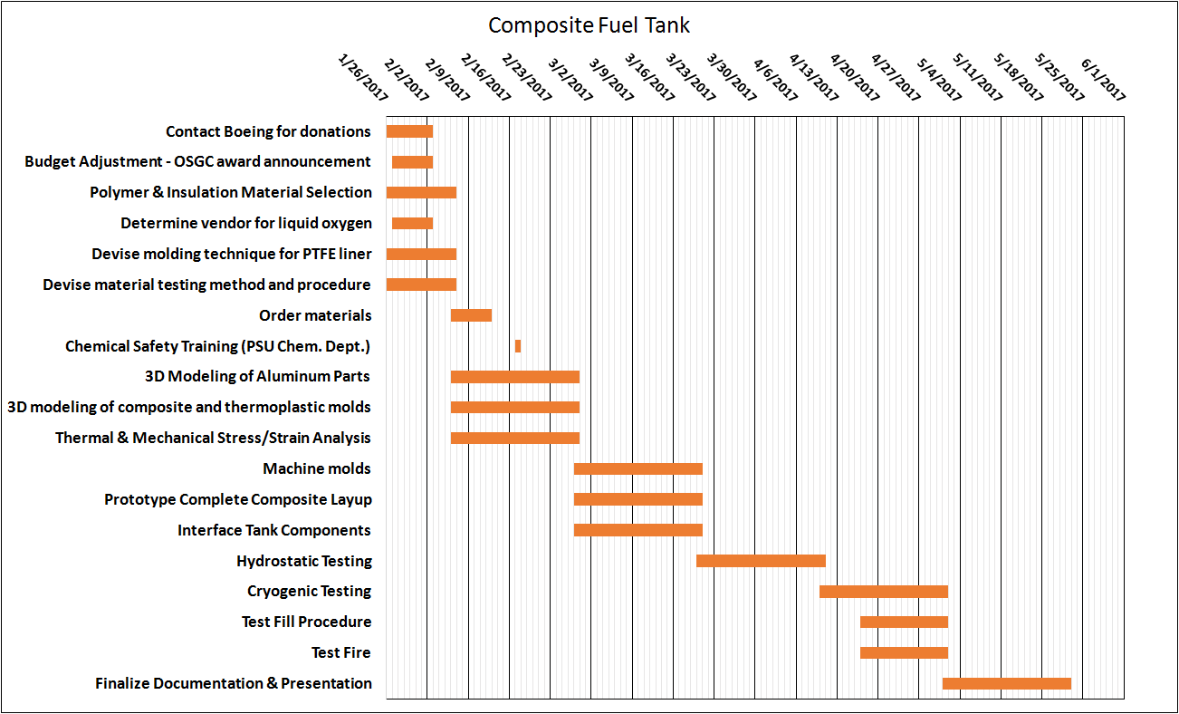

**Appendix**

Measurement Techniques and Procedures:

* Hydrotesting - to determine pressure at failure and leak points at room temp.
* ‘Hydrotesting’ with LN2 - to determine pressure at failure and leak points at operating temp.
* Coupon Reactivity tests - to determine potential material reactivity with LOX
* Weighing (scale) of potential tank wall layup / total unit weight - to compare to equivalent aluminum tank.
* Multiple cycles of chill and fill process (with LN2) and post-test microfracture analysis - to determine structural soundness of tank and reusability/expected life of tank.